**Personal Assistance for Seniors Who Are Self-Reliant**

**Assignment – I**

**Topic :** SMART HOME

**Name:** Niranjana Devi.V

**RegisterNumber:** 921019104033

**E-Mail Id :** ponvijay1971@gmail.com

**Tinker Cad :**

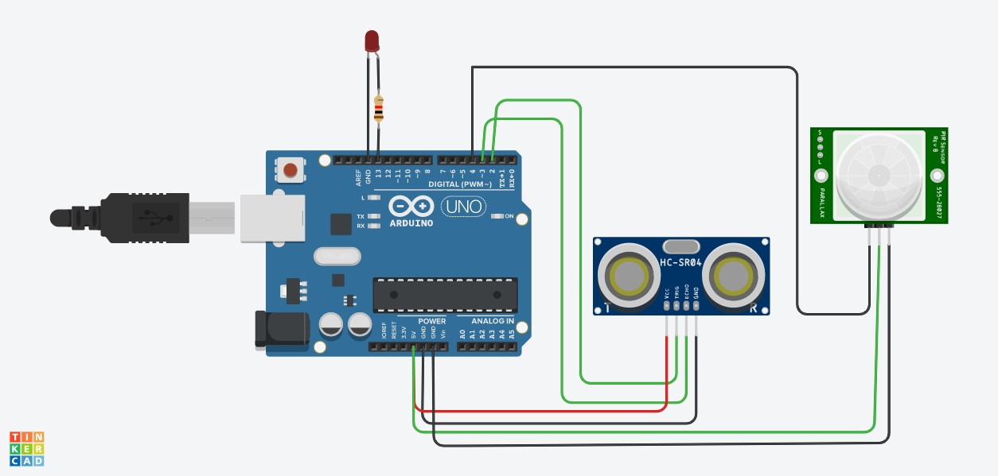

**Code:**

int trigger_pin=2; int echo_pin=3; int time; int distance; void setup()

{

Serial.begin(9600); pinMode(trigger_pin,OUTPUT); pinMode(echo_pin,INPUT); pinMode(4,INPUT); pinMode(13,OUTPUT);

} void loop() { digitalWrite(trigger_pin,HIGH); delayMicroseconds(10); digitalWrite(trigger_pin,LOW); time=pulseIn(echo_pin,HIGH); distance=(time*0.034)/2; if(distance<=10)

{

Serial.println("Door open");

Serial.print("Distance="); Serial.println(distance); delay(500); } else{

Serial.println("Door closed");

Serial.print("Distance="); Serial.println(distance); delay(500); int p=digitalRead(4); if(p)

{

digitalWrite(13,HIGH);

Serial.println("motion detected"); } else

{

digitalWrite(13,LOW); Serial.println("not detected");

}

}

}